Transferring a timetable from TimeTabler to Scheduler

The process of transferring a timetable from TimeTabler to Facility Scheduler is a fairly easy task, albeit repetitive! The main issue is that all the core data such as subjects, rooms, classgroups, teaching groups and staff have to be set up in Facility in advance. You cannot add, modify or delete any of these core data items within Facility Scheduler simply because you as the timetabler are not the only one using them! Areas such as cover, attendance, assessments, reporting, room booking etc all rely on this data. So on one hand not being able to add an extra teacher in Facility Scheduler may be seen as a disadvantage but other data that you require will have already been set up by a colleague. So it is a little swings and roundabouts.

If you wish for your timetable to be transferred for you so you can utilise your time running your school please contact MIST Services who can offer a service of transferring the timetable.

Throughout these notes it is assumed you are working in the new dataset where your timetable belongs. To help you through the process is a checklist that refers to the stages below, simply tick them off when you have done them or any questions make a note of them and contact MIST Services.

Steps within Facility Admin

Step | Completed | Notes
1 – Set up a timetable source
2 – Set up your Day structure
3 – Set up Timetabling weeks
4 – Set up a week range
5 – Set up your event specification
6 - Set up your default event template
7 – Checking your staff
8 – Check your subjects
9 – Create your teaching groups
10 – Create your timetabling classgroups (virtual classgroups)

General notes
1 – Set up a timetable source

- In Facility go to Data | Timetabling | Sources



We strongly recommend having only a single source set up and called TT (code) and Timetable (name)

2 – Set up your Day structure

- In Facility go to Data | Timetabling | Calendar | Day structure

Ensure your days are in there, if you are on a single week timetable then you shouldn’t have anything to do. We strongly recommend leaving Sunday in as Day 1 and Saturday as Day 7, simply because this will mean all the Serco default styles will work and you can still use room booking and calendar modules at the weekend.

If you do change the day structure in any way fresh refresh the database before continuing (Options | Refresh database)

3 – Set up Timetabling weeks

- In Facility go to Data | Timetabling | Calendar | Weeks

Simply type 52 weeks if you operate a one week timetable or 26 weeks if you operate a two week cycle. Having clicked on OK, please refresh the database.

This process has set up the date mappings that will be used by other modules such as lesson by lesson, cover, room bookings etc It is important to ensure that if you need to modify the date mappings they are done in advance but from a timetabling viewpoint we just need to tell Facility how many weeks our timetable could potentially run for.

4 – Set up a week range

- In Facility go to Data | Timetabling | Week ranges

We recommend setting up a single week range 1-52 for one week timetables and 1-26 for two week timetables, with all the week numbers having been selected. If you plan on building in automatic rotations you will need to revisit the week ranges and create ranges for the rotation time periods but that is beyond the scope of this short booklet. The assumption we are making here is your timetable is in essence consistent throughout the year.

5 – Set up your event specification

- In Facility go to Data | Timetabling | Event specifications

We recommend setting up a single specification for your lesson times and a separate one for your registration periods (if you are going to schedule them). This helps with manual timetabling and printouts.

6 - Set up your default event template

- In Facility go to Options | Timetabling | Edit default template

We recommend you set up the event specification, source, week range and mults to default values to speed up the data entry process in Scheduler. Remember should you have different timings for different courses then the default event template can be changed at any point either in Facility or Scheduler.

The above are very much one off tasks each year and potentially some won’t need modifying between years but it is worth checking them all!

7 – Checking you staff

- In Facility go to Staff | Staff
- Click on the Browse button at the bottom right of the window, this will list all your staff.

Please check you have the staff you want to timetable, any new appointments will need to be added in the staff window. Teachers who are no longer with the school can be removed (deleted), this will avoid lists becoming bigger than they need to be.

8 – Check you subjects

- In Facility go to Data | Academic | Master subject list

You will need to set up any new subjects you may require here.

- In Facility go to Data | Academic | School subject list

If you have created a new subject for this academic year then it will need to be added to the school list. Also if you aren’t offering a certain subject this academic year then it can be removed from the school list for this dataset (it will remain in the master subject list).

- In Facility go to Data | Academic | Course subject list

It is important to have tidy subject lists and as such it is here you can say these subjects are taught at KS3, these are taught at KS4 etc.

9 – Create your teaching groups

- In Facility go to Data | Teaching groups | Edit teaching groups

You may have some teaching groups that have been carried forward from the End of Year process. If you have we would recommend you delete duplicate teaching groups (i.e. split teaching) and also remove the teacher name. If you would like assistance in clearing the teacher names in bulk please contact MIST Services and we can explain how that is done. We would recommend that any surplus or redundant groups are also deleted. This then leaves the new or missing teaching groups to be created. When creating teaching groups you simply need to provide the Course, Year, Subject and the Code you are wasting time adding the teacher. There is a routine for that!

Looking at the demonstration data from TimeTabler the Year 7 curriculum is shown below with the teaching group codes showing. These are what you need to type into Facility.

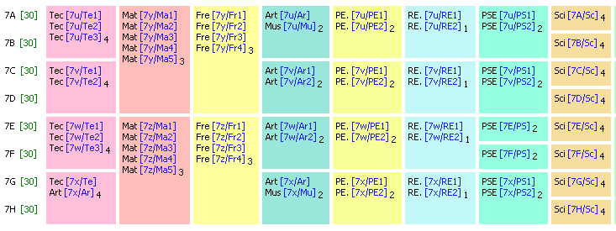

10 – Create your timetabling classgroups (virtual classgroups)

- In Facility go to Data | Academic | Classgroups

The naming of the timetabling classgroups is down to the school and is at times quite subjective. To help look at the TimeTabler demonstration Year 7 curriculum diagram.

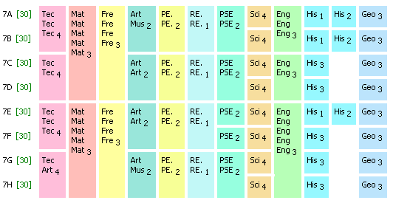

In TimeTabler the Classes are as follows:

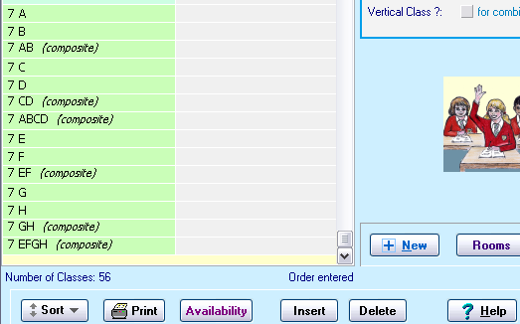

Looking at the curriculum diagram in Excel it would be drawn as follows if entered into Facility Scheduler:

Virtual Classgroup Code | Virtual Classgroup Name |  | 3 | 3 | 3 | 4 | 2 | 2 | 1 | 2 | 4 | 3 | 3
7A | 7.01 |  | Mat | Fre | Eng | Tec | Art | Pe | Re | PSE | Sci | His | Geo
7B | 7.02 |  | Mat | Fre | Eng | Tec | Mus | Pe | Re | PSE | Sci | His | Geo
7AB | 7.03 |  | Mat |  | Eng | Tec
7C | 7.04 |  | Mat | Fre | Eng | Tec | Art | Pe | Re | PSE | Sci | His | Geo
7D | 7.05 |  | Mat | Fre | Eng | Tec | Art | Pe | Re | PSE | Sci | His | Geo
7E | 7.06 |  | Mat | Fre | Eng | Tec | Art | Pe | Re | PSE | Sci | His | Geo
7F | 7.07 |  | Mat | Fre | Eng | Tec | Art | Pe | Re | PSE | Sci | His | Geo
7EF | 7.08 |  | Mat |  | Eng | Tec
7G | 7.09 |  | Mat | Fre | Eng | Tec | Art | Pe | Re | PSE | Sci | His | Geo
7H | 7.10 |  | Mat | Fre | Eng | Art | Mus | Pe | Re | PSE | Sci | His | Geo

Notice how the curriculum diagrams are virtually identical, French has been spread out slightly to denote that French gets its students from 7A, 7B, 7C and 7D.

In the ‘Code’ column are the codes we would give the virtual classgroups and the name has been given 7.01, 7.02 etc simply so that in Scheduler the classgroups display in the order above (the planning matrices MIST provide are sorted on Name and not Code).

If you are unsure what the virtual classgroups should be called then please contact us or email us the curriculum diagram from TimeTabler and we can assist.

Steps within Facility Scheduler

Step | Completed | Notes
11 - Extract your ttd file
12 – Open your ttd file in Scheduler
13 – Import TimeTabler steps planning matrices
14 – Creating your curriculum - Blocks
15 – Creating your curriculum – Pure class activities
16 – Creating your curriculum – Container blocks
17 – Associating teaching groups (students) with lessons
18 – Staffing your curriculum
19 – Manually timetabling your curriculum
20 – Rooming your timetable

General notes

11 - Extract your ttd file

- In Facility go to Database | Extract timetable to file

We would always recommend having a sensible naming convention for your extracts. Many schools will include the date.

12 – Open your ttd file in Scheduler

- Open up Facility Scheduler
- Go to File | Open

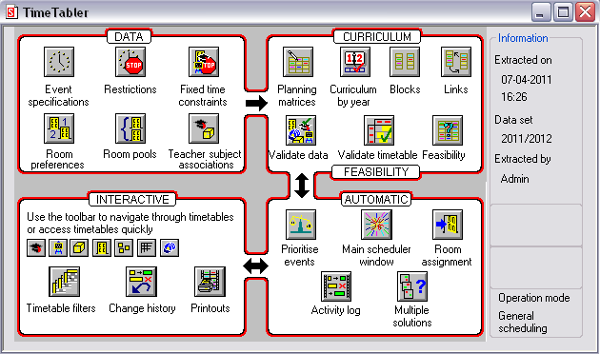

13 – Import TimeTabler steps planning matrices

Planning matrices are ‘grids’ that display timetabling information or allow the user to create timetable lessons in Facility Scheduler. To help with the transfer we have designed some planning matrices specifically for the task, they need to be downloaded and saved onto your computer. Once the .mtx file have been downloaded to your machine you can import them.

- In Scheduler go to Planning | Planning matrices | Edit matrix definitions

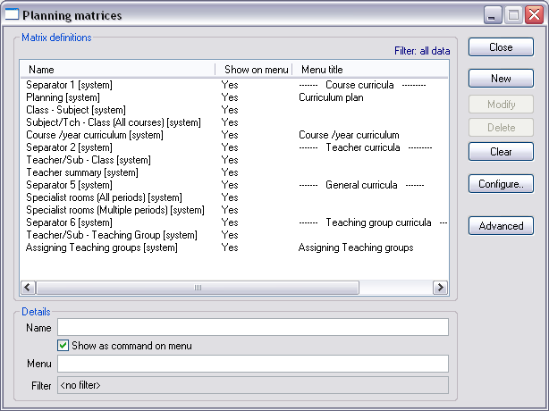

- Click on Advanced | Import
- Browse to where you have saved the TimeTabler steps.mtx

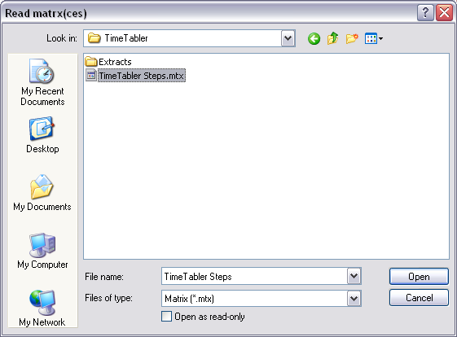

- Highlight the file
- Click on Open
- Click on Close
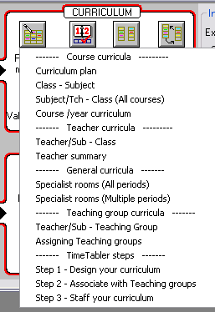

The newly imported planning matrices can be accessed by clicking on the Planning Matrices icon and seen towards the bottom of the menu under TimeTabler steps.

14 – Creating your curriculum - Blocks

To create the curriculum you should use ‘Step 1 – Design your curriculum’

- In Scheduler click on Planning matrices | Step 1 – Design your curriculum
- Filter to Year 7

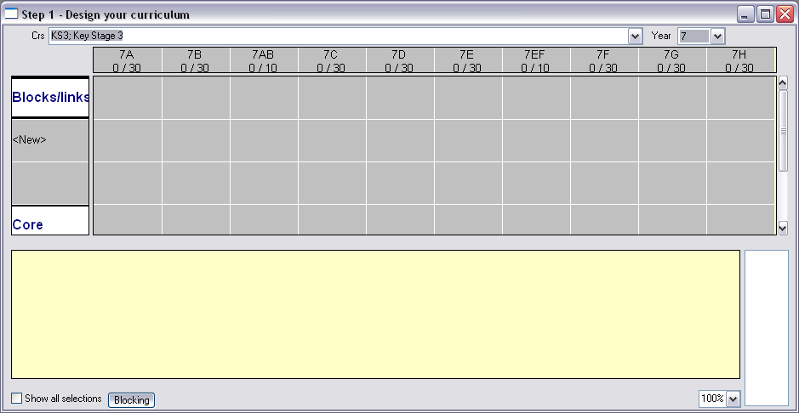

To create the TimeTabler block of Mathematics for the students in 7A, 7B, 7C and 7D:

- Multi-select the cell under 7A, 7B, 7AB, 7C and 7D

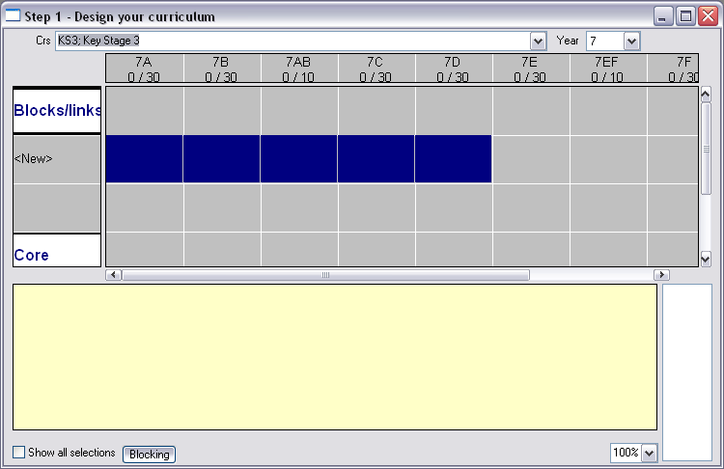

- Right click over the blue and select Create multiple groups

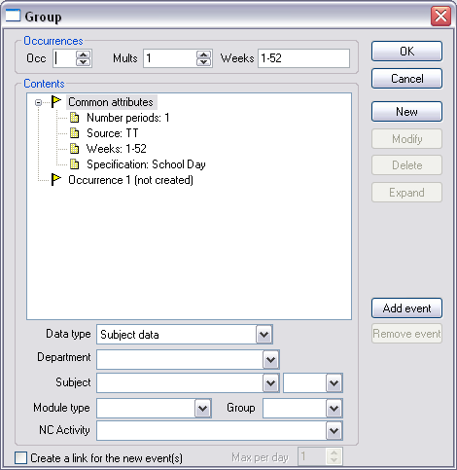

- Select Mat from the Subject drop down
- Click on New

- In the Occ field type 3 for three occurrences of Maths

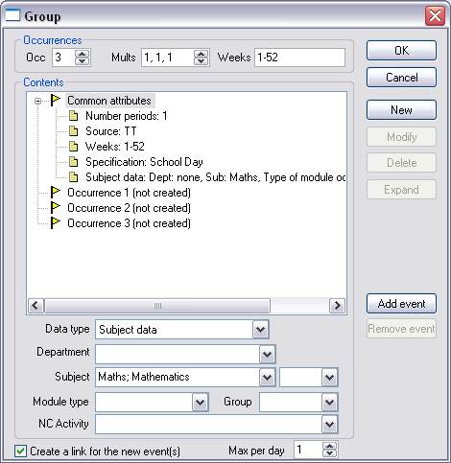

Notice how the Create a link for the new event(s) has been ticked if you know you have maths twice on a day, remove the tick here.

If Maths was actually a double and two singles you would type 2,1,1 in the mults field.

- When you have defined the subject and the period make up (Mults) click on OK

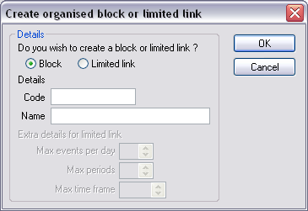

- Type a block code for example 7X-MA
- Type a block name for example 7X-Maths
- Click on OK

Repeat this for all your blocks in TimeTabler. Please note that what TimeTabler refers to as Blocks Scheduler calls them Organised Blocks.

To create the Art and Music block for 7A and 7B, we would create an organised block as above for say Art in 7A and 7B and call it 7AB/ArMu as the following image shows:

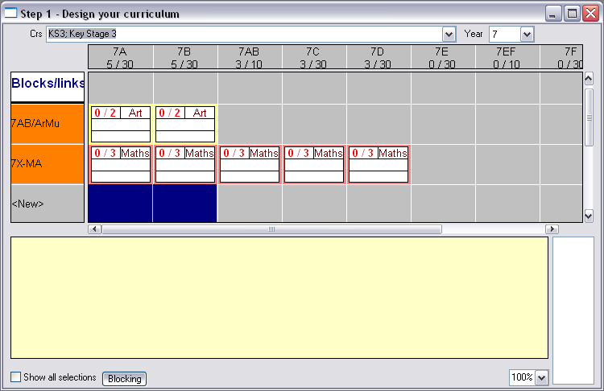

- Then double click on the Art in 7B to get the Group dialogue box

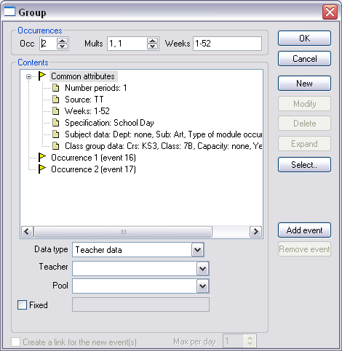

- Highlight Subject data from the Contents part

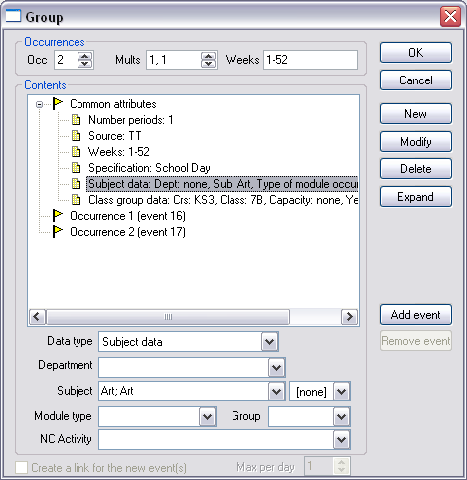

- Select Music from the drop down
- Click on Modify
- Click on OK

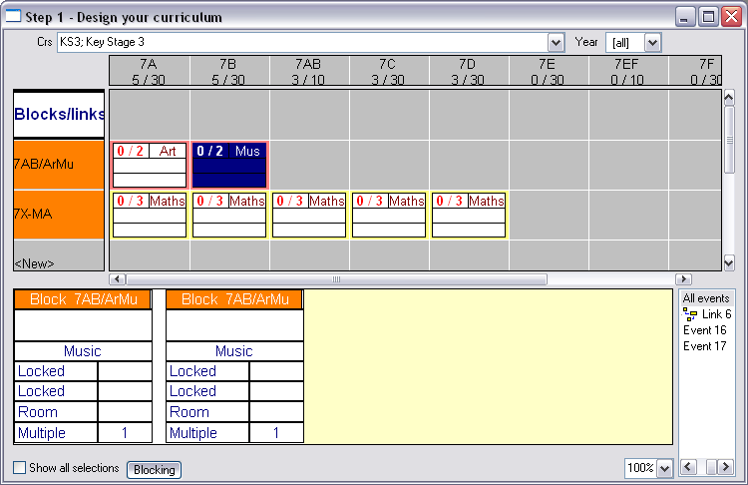

This is the technique we would suggest to use when creating option blocks in Y10 and Y11.

15 – Creating your curriculum – Pure class activities

In the Year 7 curriculum diagram everything is in a block except for Science, History and Geography which are taught as pure class activities. In Scheduler terminology these are simply ‘events’ i.e. don’t have a structure and are constructed under the ‘Core’.

- In Scheduler click on Planning Matrices | Step 1 – Design your curriculum
- Filter to Year 7

- Highlight 7A, 7B, 7C, 7D, 7E, 7F, 7G, 7H on the New row under Core

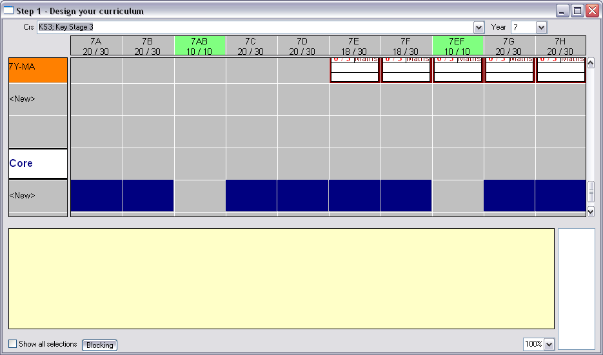

- Right click and select Create multiple groups
- Add Science into the Contents
- Type 4 in the Occurrences field

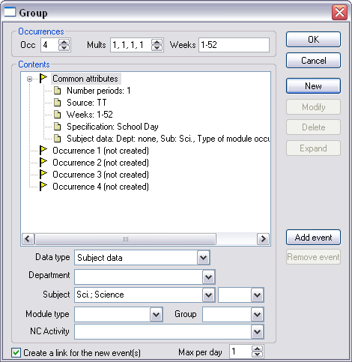

- Click on OK

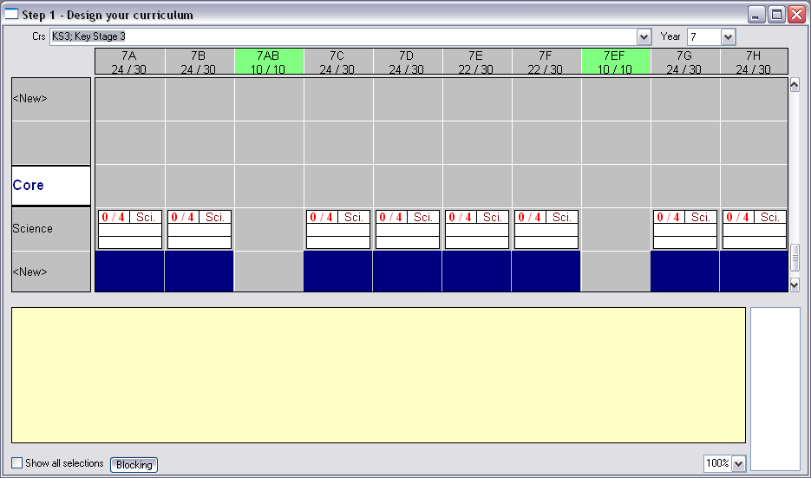

Notice how Scheduler has remembered the highlighted pattern.

Repeat the technique to create 3 single lessons of History and 3 single lessons of Geography

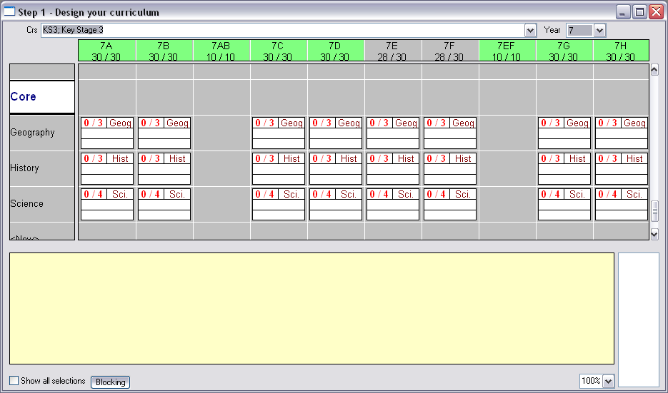

You will need to create a double PSE for 7E and 7F (they are taught as pure classes unlike the rest of PSE)

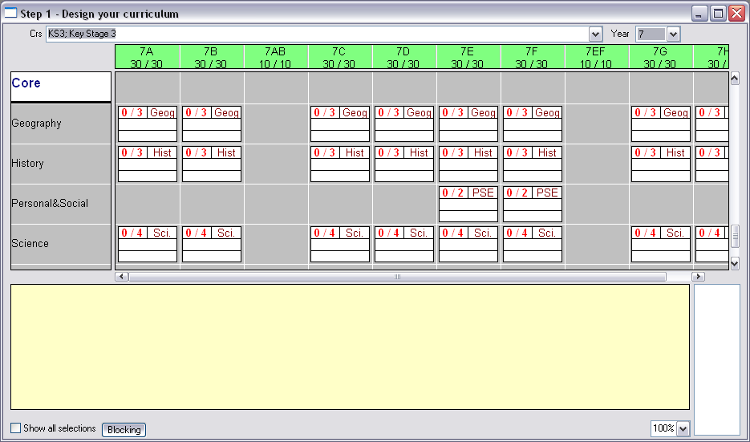

From the curriculum diagram from TimeTabler we can see that History for 7E and 7H actually get a double and a single rather than the three singles we have created.

This is easily changed. Highlight 7E History in the planning matrices.

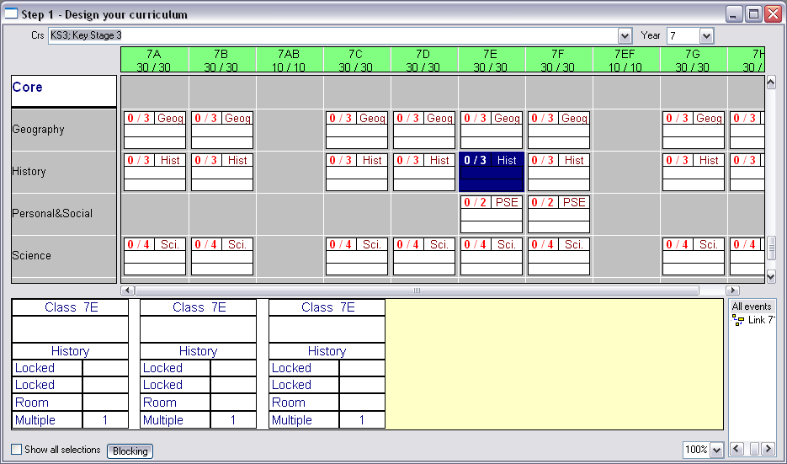

Right click on any one of the playing cards (events) at the bottom and select Delete and agree to the deletion.

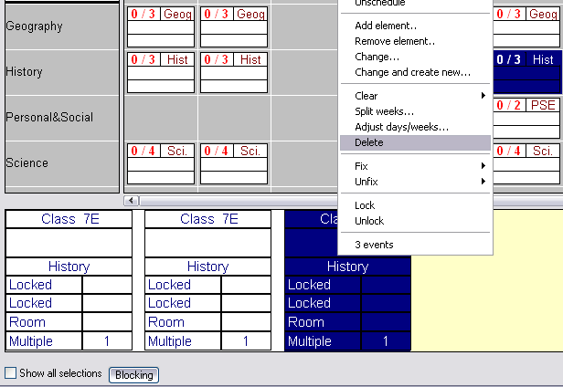

You will be left with two playing cards (two lessons) at the bottom. To change one to a double simply double click on one of the events and change the Mult field to 2.

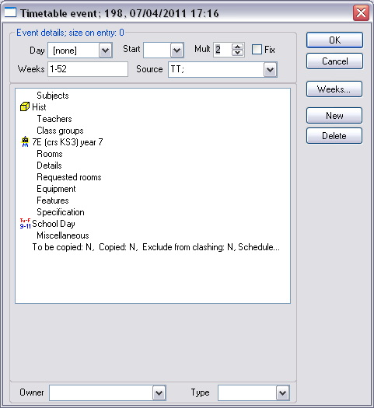

- Click on OK

Notice you have two playing cards one is a single and one is a double.

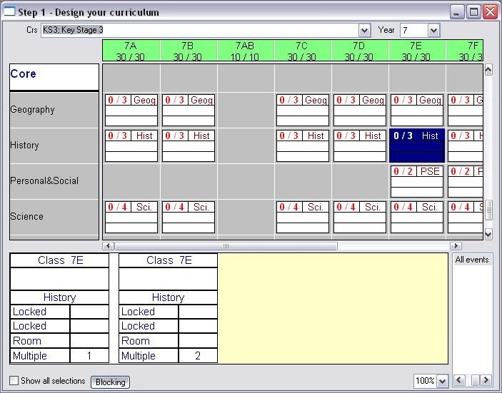

- Repeat this for 7H History

16 – Creating your curriculum – Container blocks

In the Year 7 curriculum there is no need to use container blocks but to illustrate how you would create one in Scheduler we will pretend Science, History and Geography actually needed one. In Scheduler a container block is known as a limited link. The curriculum diagram shows the four container blocks (limited links), but please appreciate we are only doing it for demonstration purposes as limited links wouldn’t actually be required.

Code | Name |  | 3 | 3 | 3 | 4 | 2 | 2 | 1 | 2 | 4 | 3 | 3
7A | 7.01 |  | Mat | Fre | Eng | Tec | Art | Pe | Re | PSE | Sci | His | Geo
7B | 7.02 |  | Mat | Fre | Eng | Tec | Mus | Pe | Re | PSE | Sci | His | Geo
7AB | 7.03 |  | Mat |  | Eng | Tec
7C | 7.04 |  | Mat | Fre | Eng | Tec | Art | Pe | Re | PSE | Sci | His | Geo
7D | 7.05 |  | Mat | Fre | Eng | Tec | Art | Pe | Re | PSE | Sci | His | Geo
7E | 7.06 |  | Mat | Fre | Eng | Tec | Art | Pe | Re | PSE | Sci | His | Geo
7F | 7.07 |  | Mat | Fre | Eng | Tec | Art | Pe | Re | PSE | Sci | His | Geo
7EF | 7.08 |  | Mat |  | Eng | Tec
7G | 7.09 |  | Mat | Fre | Eng | Tec | Art | Pe | Re | PSE | Sci | His | Geo
7H | 7.10 |  | Mat | Fre | Eng | Art | Mus | Pe | Re | PSE | Sci | His | Geo

To create the limited link you create the lessons for Science, History and Geography in exactly the same way as above. When they are created we can group the lessons (events) together.

- Highlight the History, Geography and Science lessons for 7A and 7B.

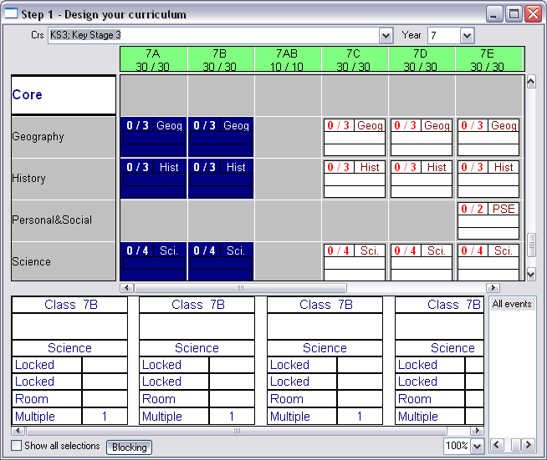

- Right click over the blue and select Create | Link with limit

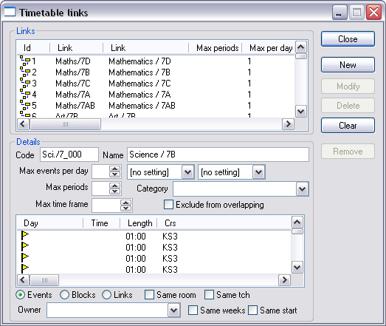

- Type 10 in the Max periods field as this the number of periods the lessons are going to fit into on the timetable.
- Type 7AB-HiGgSc in the Code and Name field

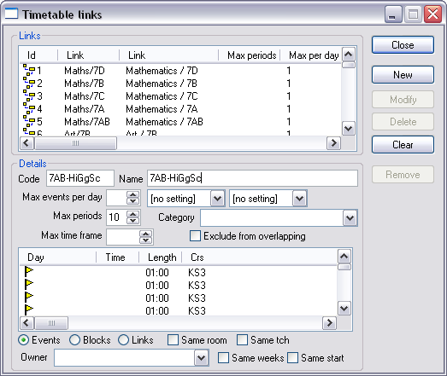

- Click on New

Notice how it has been removed from the Core to the Blocks/Links section and has been coloured Green.

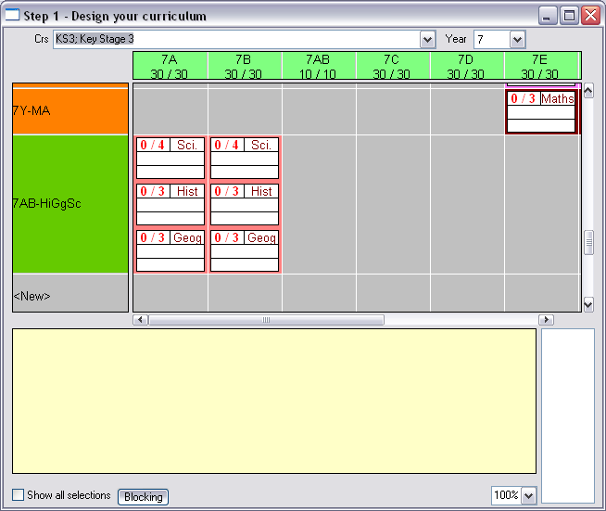

Repeat for the other container blocks, in our example 7E and 7F would occupy 12 periods simply because PSE isn’t blocked.

17 – Associating teaching groups (students) with lessons

Within Facility you have set up teaching groups which will accommodate the student needs in respect to their subject curriculum. It should be noted that whilst you are constructing your timetable a colleague could be populating the groups within Facility so that the individual student timetables can be printed as soon as your timetable is complete.

- In Scheduler go to Planning matrices | Step 2 – Associate with teaching groups
- Filter to Year 7

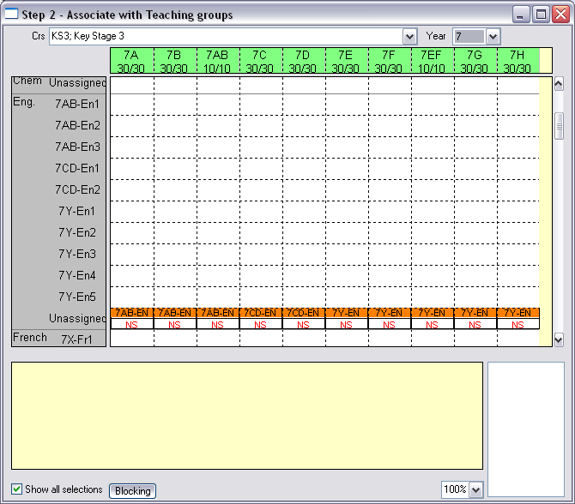

Scroll down to the Subject and you will see the lessons (events) sitting on the ‘Unassigned’ row. This means the lessons haven’t yet been given a group of students (teaching group). In our example in the 7A column the events are in the organised block called 7AB-EN highlight the group of events to select them, release your mouse and then click and drag them up vertically to the 7AB-En1 row.

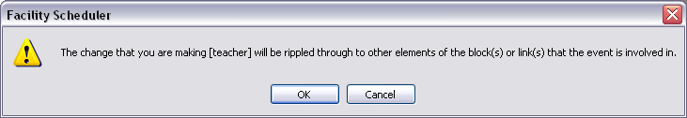

If you get the following message click on OK, you will need to do this for the number of cards you are giving away. If you didn’t want to give all the cards away you can cancel a couple of the cards. If you are finding the message is slowing you down it can be turned off. For details of this please contact MIST Services.

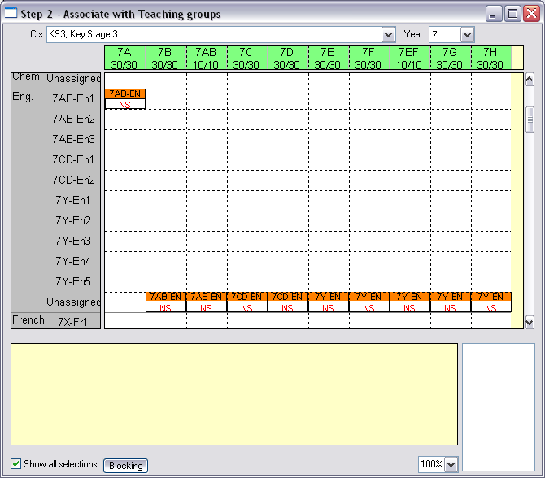

Repeat for all events.

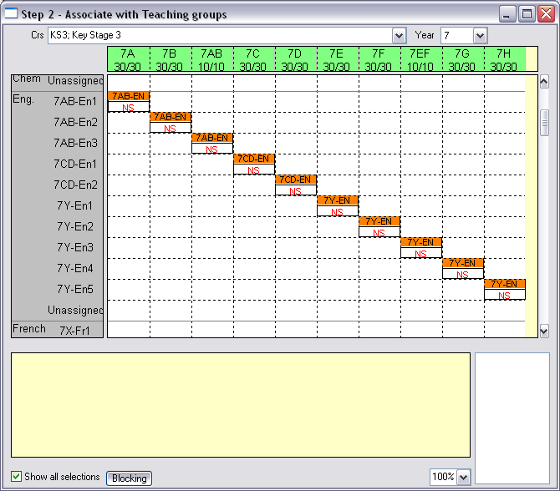

If you looked at the Step 1 – Design your curriculum matrix it will look like:

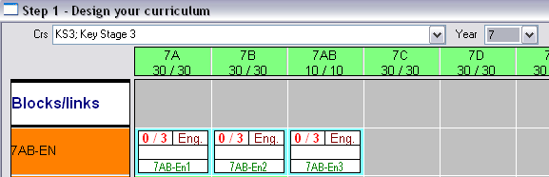

If you wished to associate teaching groups from other planning matrices for example in Step 1 – Design your curriculum matrix, double click on the group of events.

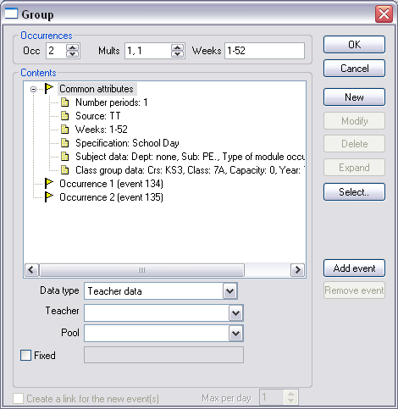

Here 7A, PE has been double clicked and as no teacher has been added Scheduler has Data type highlighted at the suggesting a teacher or teaching group should be added.

- Click on Select

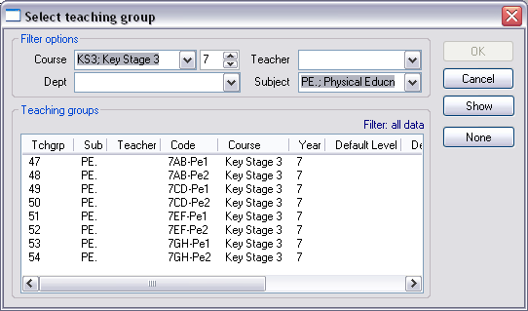

- Double click on 7AB-Pe1

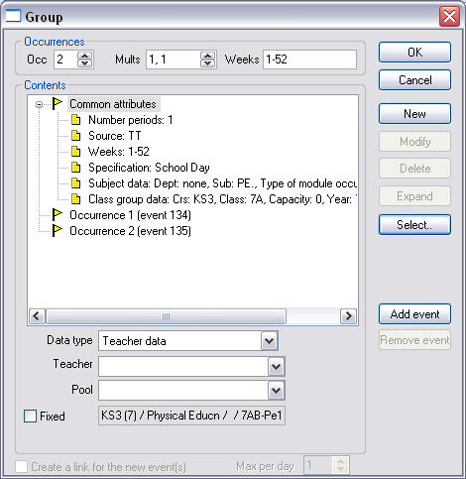

- Click on New

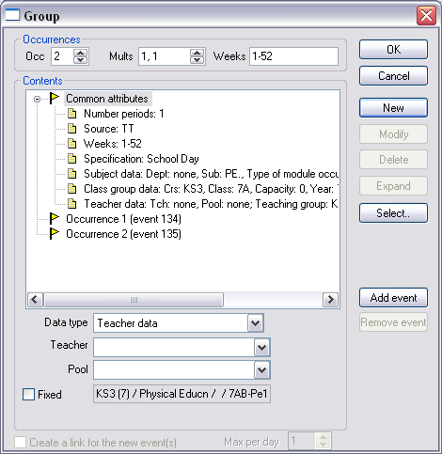

- Click on OK

You can see the teaching group label has been added (the green label). This will be visible in the Step 2 – Associate teaching groups planning matrix

Repeat the association for all lessons. If you are unsure if you have associated all events to a teaching group you can use filtering techniques in the ‘Automatic scheduling’ window. For more details contact MIST Services.

18 – Staffing your curriculum

Before you can staff your curriculum you need to tell Scheduler who you want to teach English, compared to Maths etc. Please note a teacher can teach many subjects. If the association isn’t made then Scheduler won’t automatically give you maths teachers when you are staffing maths lessons.

- In Scheduler go to Data | Academic | Teacher – subject associations (there is a shortcut on the control path)

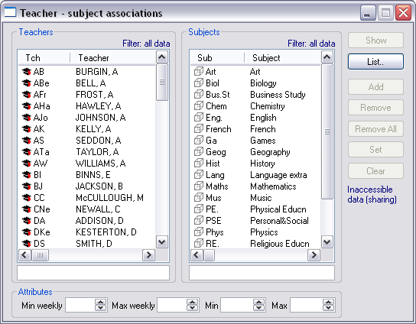

- Highlight the teacher in the Teachers window
- Double click on the Subject in the Subjects window that you want them to teach
- Click on Set

Repeat accordingly.

It might be more efficient to operate to the other way i.e. the Teachers and Subjects window swapped around. To operate this way:

- In Scheduler go to Data | Academic | Subject – teacher associations

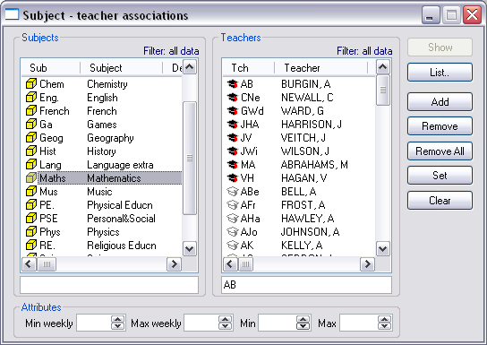

Having made the associations you can now staff your curriculum.

- In Scheduler go to Planning matrices | Step 3 – Staff your curriculum

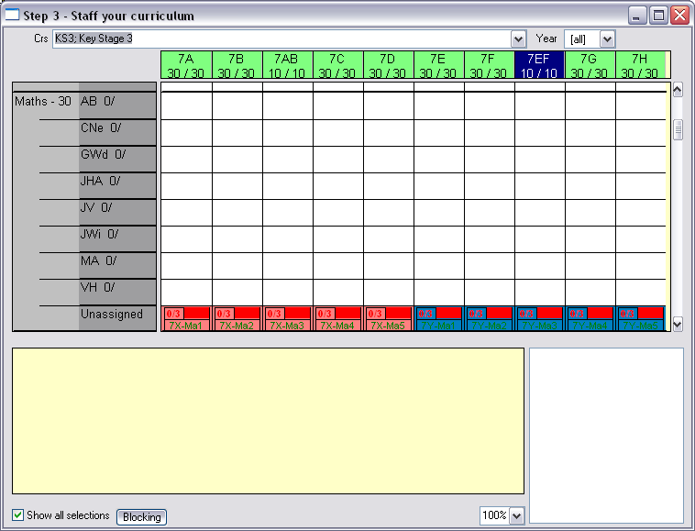

Please note if we have told Scheduler that AB can only teach 21 lessons then it would show 0/21, with the 0 increasing as we allocate lessons to them.

- Drag 7X-Ma1 vertically up to JHa

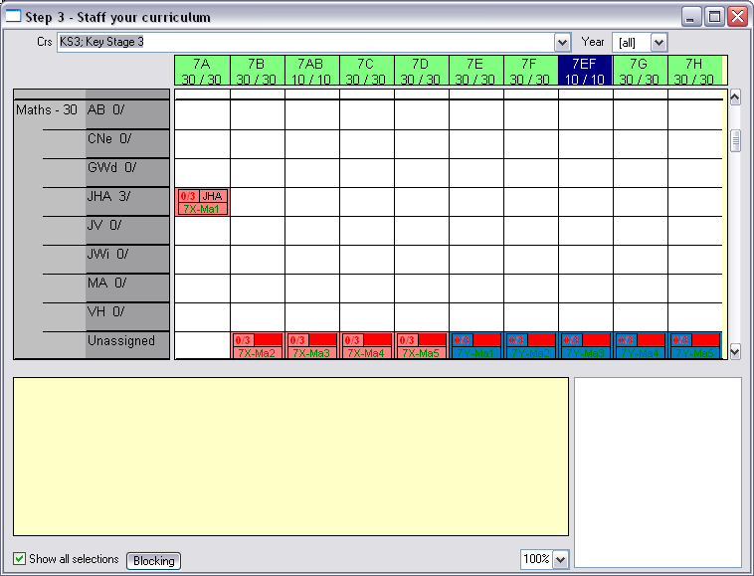

If you get the ‘ripple’ message click on OK for as many cards (lessons) you wish to give away.

If you wish to staff your curriculum from another matrix for example Step 1 – Design your curriculum.

- Double click the group of events for example the 7B, Maths

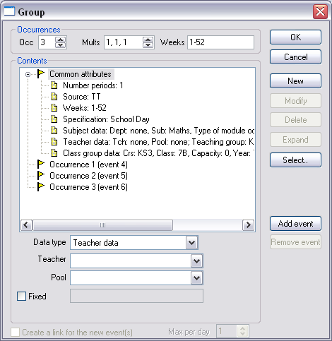

- Highlight the Teacher data row from the contents window

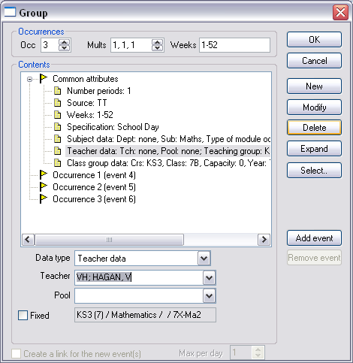

- Click on Modify

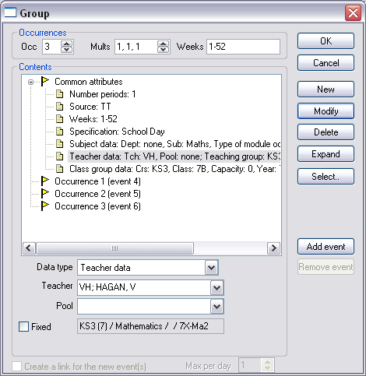

- Click on OK

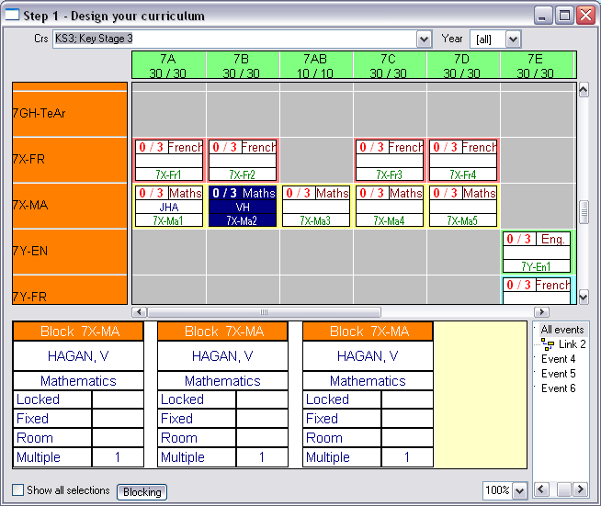

Notice how the teacher is displayed in the middle row.

Should you wish to change the teacher for a single card (lesson) rather than all three, simply double click at the card level and change the teacher there.

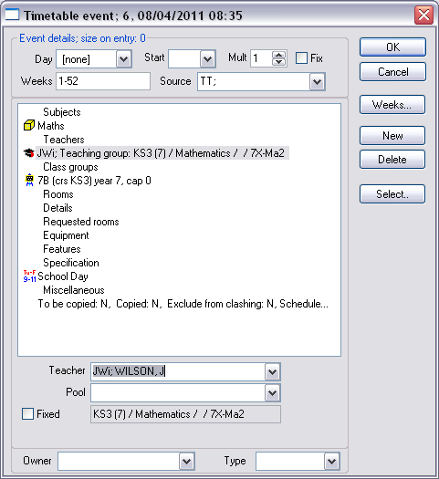

The planning matrix will then show the ‘split’ group.

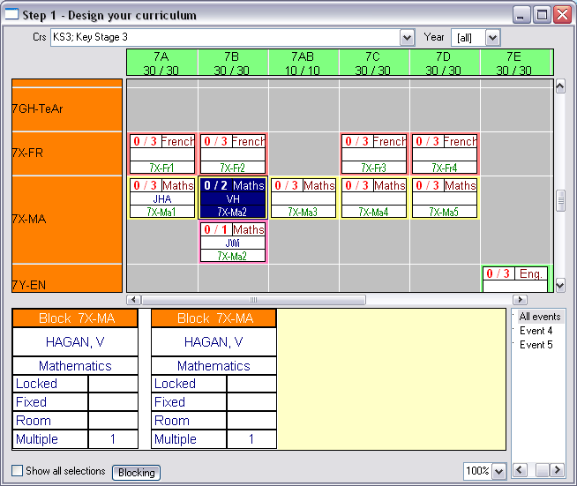

Repeat the staffing for your entire curriculum. If unsure whether you have staffed all your curriculum, remember you can use filtering techniques within the ‘Automatic scheduling’ window, for help on this please contact MIST Services.

It should be noted that some schools schedule the timetable before allocating staff, as far as Scheduler is concerned it doesn’t matter in the order as you are copying a timetable that you know fits!

19 – Manually timetabling your curriculum

There are many ways (and views) in which you can manually timetable so it is important to find a screen that you feel confident with and compliments the format you have your TimeTabler printouts in.

To enter the Year 7 timetable we would either print out timetables for 7A, 7B, 7C etc or print out the master class timetable for Year 7.

Here is the single class timetable from TimeTabler
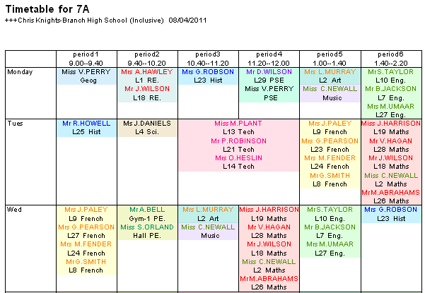

Here is part of the master class timetable from TimeTabler

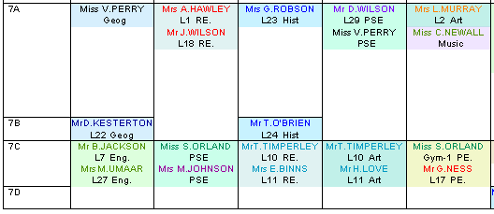

To enter your timetable from the ‘class’ timetable start off by having 7A timetable from TimeTabler printed out and in front of you.

In Scheduler double click on the Class icon under interactive (blackboard icon)

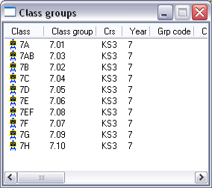

- Double click on 7A

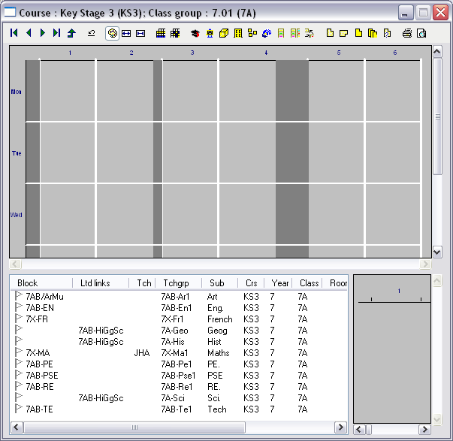

From our printout TimeTabler says Geography for 7A is on Monday period one:

- Select the white flag on the Geography row

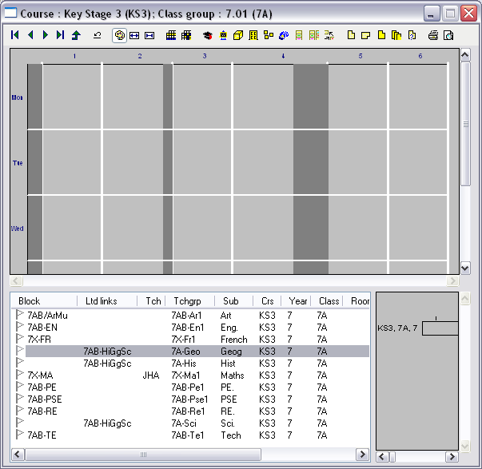

- Drag the white flag to the start of Monday Period 1 and drop the flag

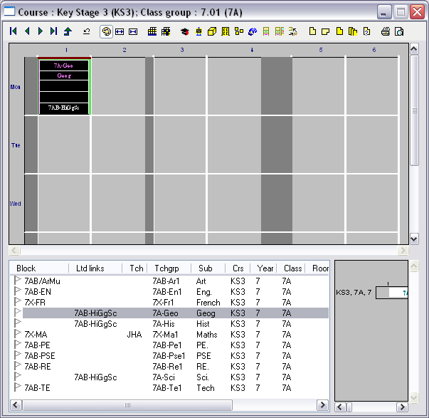

Because you already have Geography highlighted you could look at your printout to see where else Geography was timetabled and place them in those periods. Or if you prefer you can just look to see what is on Monday period 2 from the timetable and drag that flag onto the timetable.

In the screenshot below you can see I have manually timetabled 7A on Monday. If I look at 7B’s timetable, you will see any organised blocks that were used by 7B have already been timetabled.

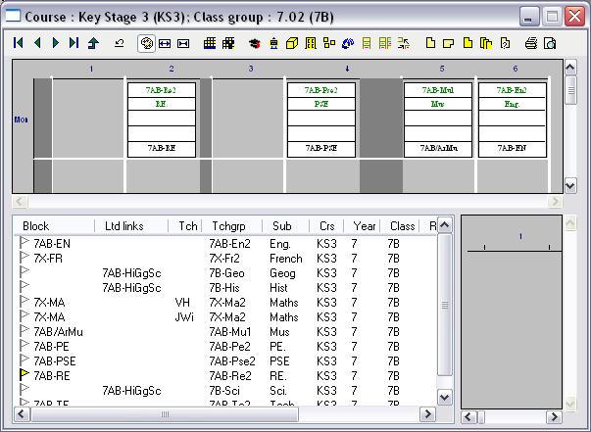

Repeat this process for the rest of your curriculum. Please remember that this technique is the same whether you are looking at individual or master staff, class, subject, room timetables. You can decide what the easiest or quickest method is for you. The obvious advantage of say a master class timetable is you see the whole year group building up in one go, rather than just looking at a single class.

If you get familiar with the planning matrices you can double click on the card and simply select the day and time from the drop down menus:

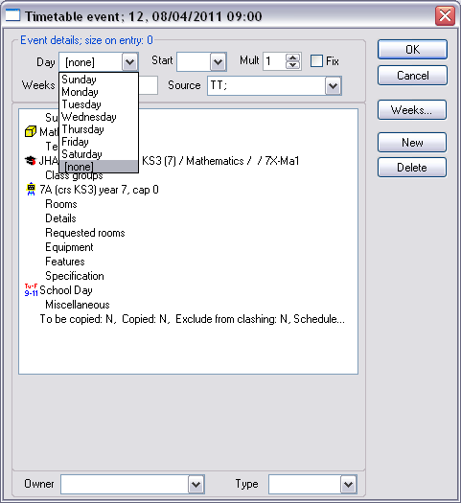

Coming back to the point about some schools manually timetable their curriculum first and then staff it later. This can easily be done as you can see the Day and Time of the cards at the bottom as can be seen below:

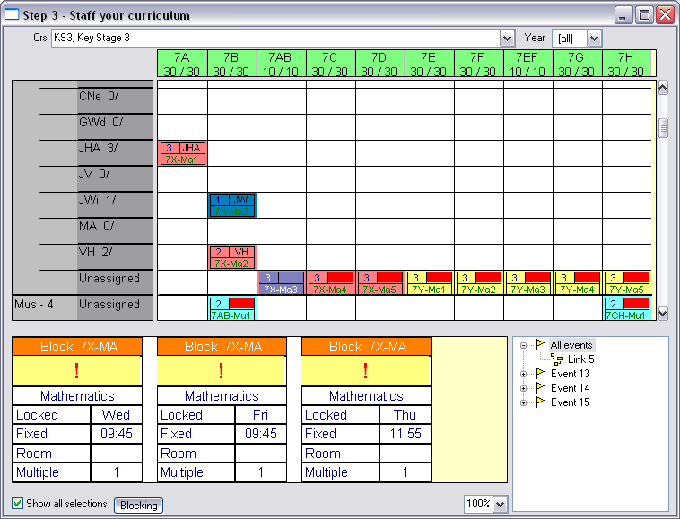

- If you wanted to give the Wednesday and Thursday lesson to CNe when you get the ripple message you would say OK, Cancel and OK

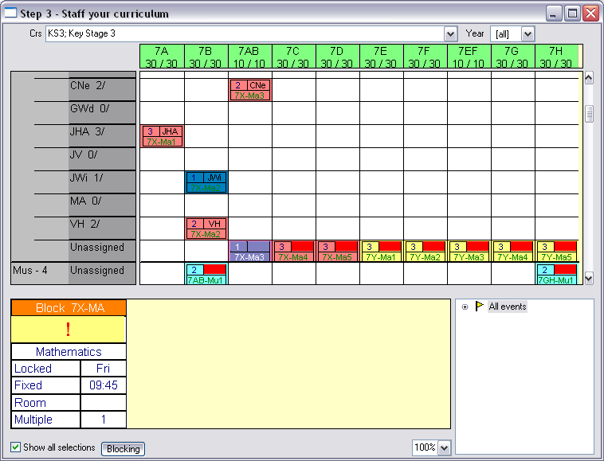

This leaves the Friday card to be dragged up to another teacher, let’s say JV

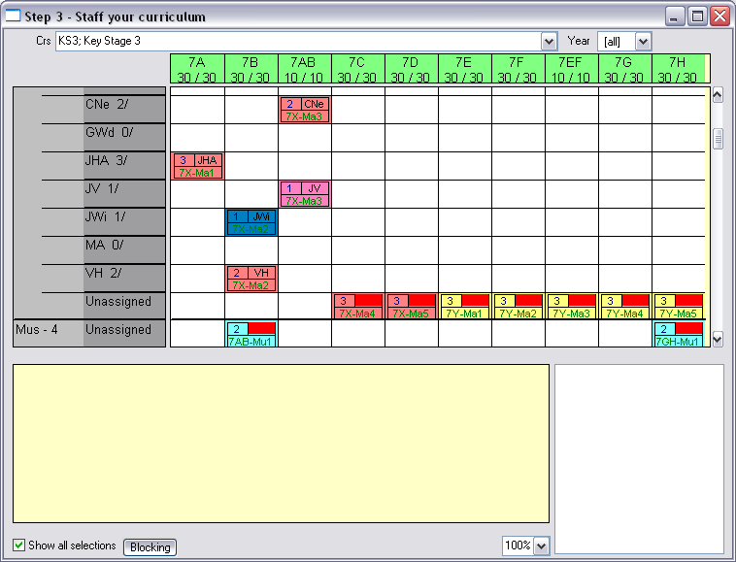

Because of this technique many schools construct the post 16 option blocks as ‘Organised blocks’ rather than ‘Limited links’, meaning you schedule the block (as it does all the block rather than lesson by lesson) and then assign the staff in the correct order.

Should you wish for any clarification on this please contact MIST Services.

20 – Rooming your timetable

Within Scheduler they are many different ways to room your timetable, whether that is changing at event level, group of events, by using bulk change functionality or using Scheduler to automatically assign the rooms. The method you use depends slightly on the association of rooms to teachers and subjects. Should you wish to discuss one method over another please contact MIST Services.

The method below describes the use of planning matrices to room your timetable.

- In Scheduler go to Planning matrices | Step 4 – Room your timetable

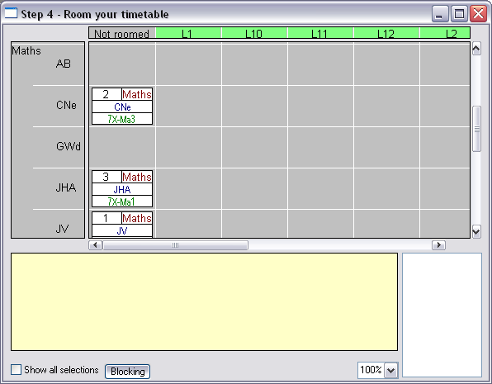

You will see all your rooms if you want to hide certain rooms to make the assignment easier multi select the rooms you wish to hide and right click | Hide

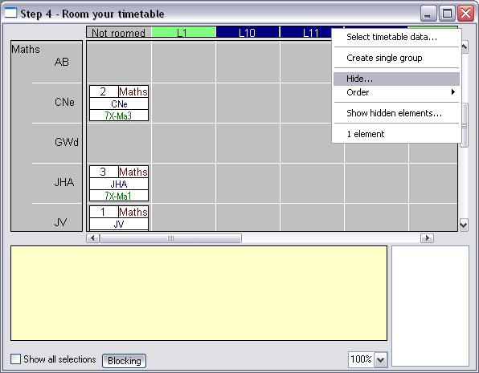

Scroll down to the subject area and you will see all the teachers of that subject and all of their lessons (for that subject).

- If you wish CNe to be in L1, simply drag the events across. Repeat this for the rest of your timetable.

